Controlled Vocabulary Practical Exercise

# SeaDataNet Vocabulary Identification

Which SeaDataNet vocabulary would be used to populate the following metadata model or data file field?

* Cruise Summary Report (CSR) cruise start and end ports
* The country in which a port is located
* Sea areas in an EDMED record (clue: it's not C16)
* Spatial feature type in CDI record
* Common Data Index (CDI) instrument type
* ODV or NetCDF data file instrument semantic linkage
* EMODNET product parameter
* CDI parameter
* ODV or NetCDF data file parameter semantic linkage

# REST Time

* Obtain the RDF XML catalogue of the controlled vocabularies held in the NERC Vocabulary Server
* Obtain the RDF XML document listing the deprecated concepts in the P02 vocabulary
* What accepted P02 code should be used instead of the deprecated P02 code MTSD?

# Instrument Mappings

* What are the L05 URIs (URN and URL) for a dissolved oxygen sensor?
* What dissolved oxygen sensors are included in L22?
* What are the L22 and L05 URNs for a Sea-Bird SBE9-11plus CTD?

# Parameter mappings

* Find an appropriate P01 URN to match to each of the following local parameters:
  + Concentration of suspended particulate material (GF/C filtered)
  + PCB101 in sediment fines (<63um)
  + Fluorometric chlorophyll-a (acetone extraction GF/F filtered)
  + Temperature (C)
  + Phosphate (uMol/l) in an unfiltered sample
  + Dissolved zinc (uMol/kg). Dissolved defined as 0.2um filtered.
  + Particulate cadmium (ppb)
  + Concentration of cadmium in mussels (ug/kg)
  + Concentration of mercaptothion in filtered water (ug/l)
  + Optical backscatter at 470 nm at 117 degrees (per m)

# Green Dogs

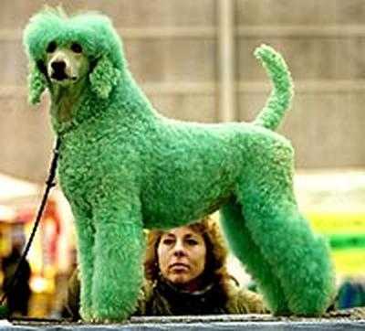

Which of the following parameter descriptions are the six 'Green Dogs' and why?

* Practical salinity standard deviation of the water body by CTD and computation using UNESCO 1983 algorithm and calibration against independent measurements
* Practical salinity per unit dry weight of sediment <63um
* Concentration of Thalassiosira gravida (ITIS: 2490: WoRMS 149102) [Size: 25um] per unit volume of incubated water sample by optical microscopy
* Concentration of 2,3',4,4',5-pentachlorobiphenyl {PCB118 CAS 31508-00-6} per unit volume of the water body [dissolved plus reactive particulate <GF/F phase]
* Concentration of 2,3',4,4',5-pentachlorobiphenyl {PCB118 CAS 31508-00-6} per unit volume of the water body [dissolved plus reactive particulate >GF/F phase]
* Concentration of 2,3',4,4',5-pentachlorobiphenyl {PCB118 CAS 31508-00-6} in the water body [dissolved plus reactive particulate <GF/F phase]
* Abundance of Thalassiosira gravida (ITIS: 2490: WoRMS 149102) [Size: 25um] per unit volume of incubated water sample by optical microscopy
* Count of zinc per unit dry weight of sediment <63 um
* Count of Demospongiae (ITIS: 47528: WoRMS 164811) [Size: height ~10cm, diameter 30cm Morphology: mass of branches Colour: brown] on the bed by image analysis
* Temperature